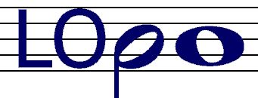
London Orpheus Philharmonic Orchestra

Friends of LOPO

I would like to become a “friend” of LOPO. I understand that I will receive occasional correspondence, newsletters, etc concerning the orchestra and events (mostly by e-mail). Please PRINT clearly:

Name: ____________________________________

Address: ____________________________________

____________________________________

Town: ____________________________________

Post code: ____________________________________

e-mail: ____________________________________

Please complete and return this form:

LOPO
58 Devonshire Road
London
W4 2HB

www.lopo.org.uk/friends

